Sub-QueryandCorrelatedSub-Query:

1. Whichofthestudent’sscoreisgreaterthanthehighestscore?
2. Whichofthestudents’havewrittenmorethanone assessmenttest?
3. Whichfacultyhasjoinedrecentlyandwhen?
4. Listthecourseandscoreofassessments thathavethevaluemorethantheaveragescoreeachCourse

##### OUTPUTS:

1)

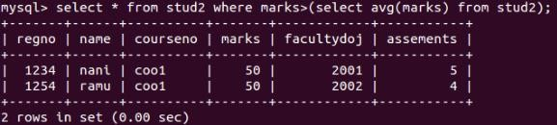

2)



3)

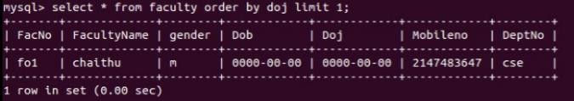

4)

